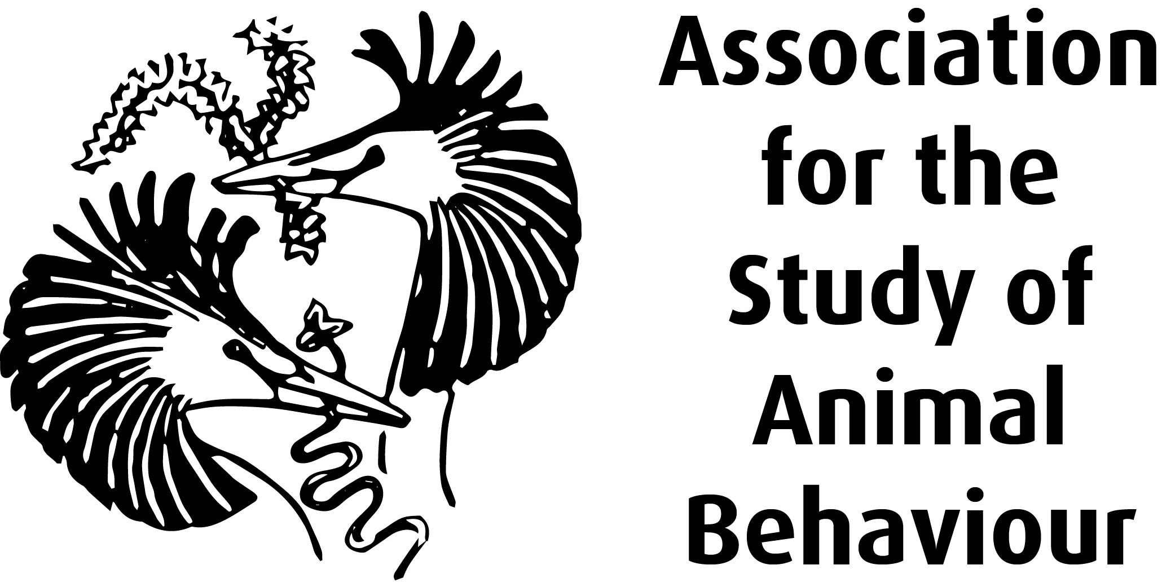
What is being investigated?
Have you ever camped in the open air or had a BBQ in the garden and found that you too were on the menu? Being bitten by mosquitoes or midges seems like an annoying part of normal life and racing to the supermarket to buy insect repellent is part of the summer experience. In some countries diseases carried by mosquitoes (vectors) and other insects are life threatening to many animals. For example mosquitoes are vectors of parasitic Bot Flies which cause debilitation and risk of secondary infection in non human primates.
It may not surprise you then to hear that other animals besides humans use insect repellent. Many animals release chemicals in defence when attacked or provoked. As a child you may have been familiar with the cartoon image of a skunk spraying when attacked. Several research papers have alluded to the fact that animals may use chemicals released by other animals as chemical deterrents.
Aim: Between the late 1970s and late 1990s researchers in Venezuela and New York studied the behaviour of a particular group of capuchin monkeys (Cebus olivaceous) that rub (anoint) defensive secretions of millipedes (Orthoporus dorsovittatus) into their fur. Their aim was to identify the chemicals secreted by the millipedes. A secondary aim was to determine the function of the fur rubbing (anointing).
Methods: Researchers observed wild capuchin monkeys in behavioural studies (ad lib sampling/scan sampling) in the forests of central Venezuela and recorded when they anointed themselves (anointment bouts) or others with the secretions of millipedes. Seasonal flooding (between May and October) in these forests results in an increase in mosquito numbers. A scientist at the Museum of Natural History in Virginia identified the millipede as O. dorsovittatus. The defensive secretions of O. dorsovittatus (six samples) were analysed by gas chromatography- mass spectrometry.
Results: In a total of 87 recorded anointing bouts, 46% involved the sharing of one millipede with another/other capuchin monkeys. The monthly incidence of anointment bouts correlated positively with the distribution of rainfall in 1978 and 1995. In 1998 there was no significant correlation between rainfall and anointment bouts. However, anointment bouts were high even though rainfall decreased in the last month of sampling. Of 15 millipedes collected some were torn apart, others decapitated, some survived and recovered. Inspection of the insides of the millipedes discarded by the monkeys showed no evidence of a lack of internal contents which led the researchers to conclude that the monkeys derived no nutrition from them. The chemical composition of the millipedes secretion contained two types of volatile components: 2-methyl-1, 4-benzoquinone and 2-methoxy-3-methyl-1, 4-benzoquinone.
Discussion and conclusion: Results pointed to a correlation between anointment bouts and monthly rainfall and hence increased mosquito numbers. No direct evidence was presented that capuchins were less vulnerable to insect attack after anointment. As the monkeys exclusively anointed with the benzoquinone secretions of the millipede in the rainy season, when mosquito levels were at their highest, the researchers propose that the purpose of the anointment was to acquire the benzoquinone secretion and spread it over their fur.
Previous studies have shown that benzoquinones are potent insect repellents, topical irritants and have antimicrobial potency. Benzoquinones are also toxic and carcinogenic in rats. Persistent exposure may have negative long term effects on capuchins as well. The researchers propose that the capuchins acquire the capacity to repel mosquitoes by anointing with O. dorsovittatus secretions. They suggest that the risk associated by anointing may be overridden by the benefit of the chemical detterent; a benefit that may have promoted the evolution of anointment behaviour in this species of capuchin monkey.

Having read the paper carefully – ask yourself does this research paper demonstrate what the function of anointing is in Cebus Olivaceous ?

